# DAD 220 Database Documentation Template

Complete these steps as you work through the directions for Project One. Replace the bracketed text with your screenshots and brief explanations of the work they capture. Each screenshot and its explanation should be sized to approximately one quarter of the page, with the description written below the screenshot. Follow these rules for each of the prompts and questions below. Review the example document located in the Project One Supporting Materials for assistance.

## Step One: Create a Database

1. Navigate to your online integrated development environment (IDE). List and record the SQL commands that you used to complete this step here:

Code used: Mysql

1. Create a database schema called QuantigrationUpdates. List out the database name. Provide the SQL commands you ran against MySQL to successfully complete this in your answer:

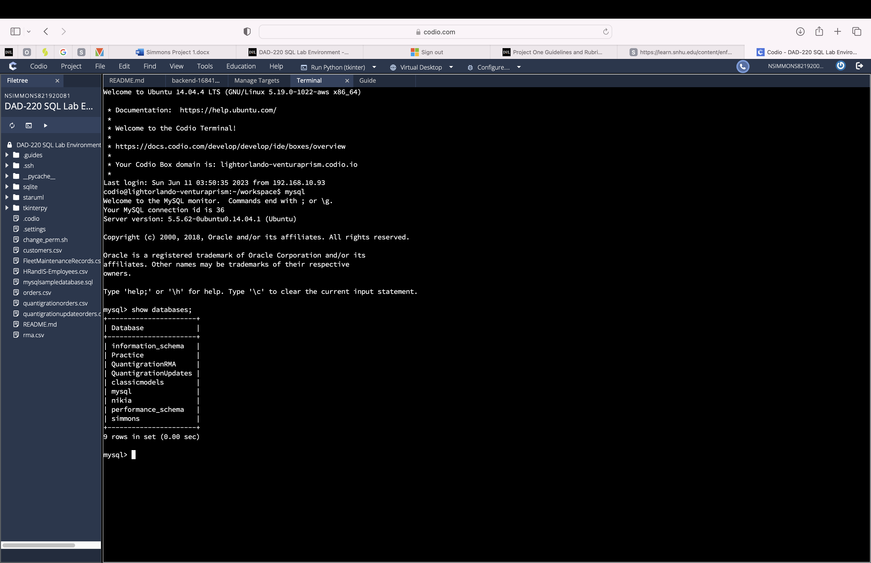

Code used: CREATE DATABASE QuantigrationUpdates;

1. Using the entity relationship diagram (ERD) as a reference, create the following tables with the appropriate attributes and keys:
   1. A table named **Customers** in the QuantigrationUpdates database, as defined on the project ERD. Provide the SQL commands you ran against MySQL to complete this successfully in your answer:

Code used:

CREATE TABLE Customers (

CustomerID INT PRIMARY KEY,

FirstName VARCHAR(25),

LastName VARCHAR(25),

Street VARCHAR(50),

City VARCHAR(50),

State VARCHAR(25),

ZipCode VARCHAR(10),

Telephone VARCHAR(15) ) ;

* 1. A table named **Orders** in the QuantigrationUpdates database, as defined on the project ERD. Provide the SQL commands you ran against MySQL to complete this successfully in your answer:

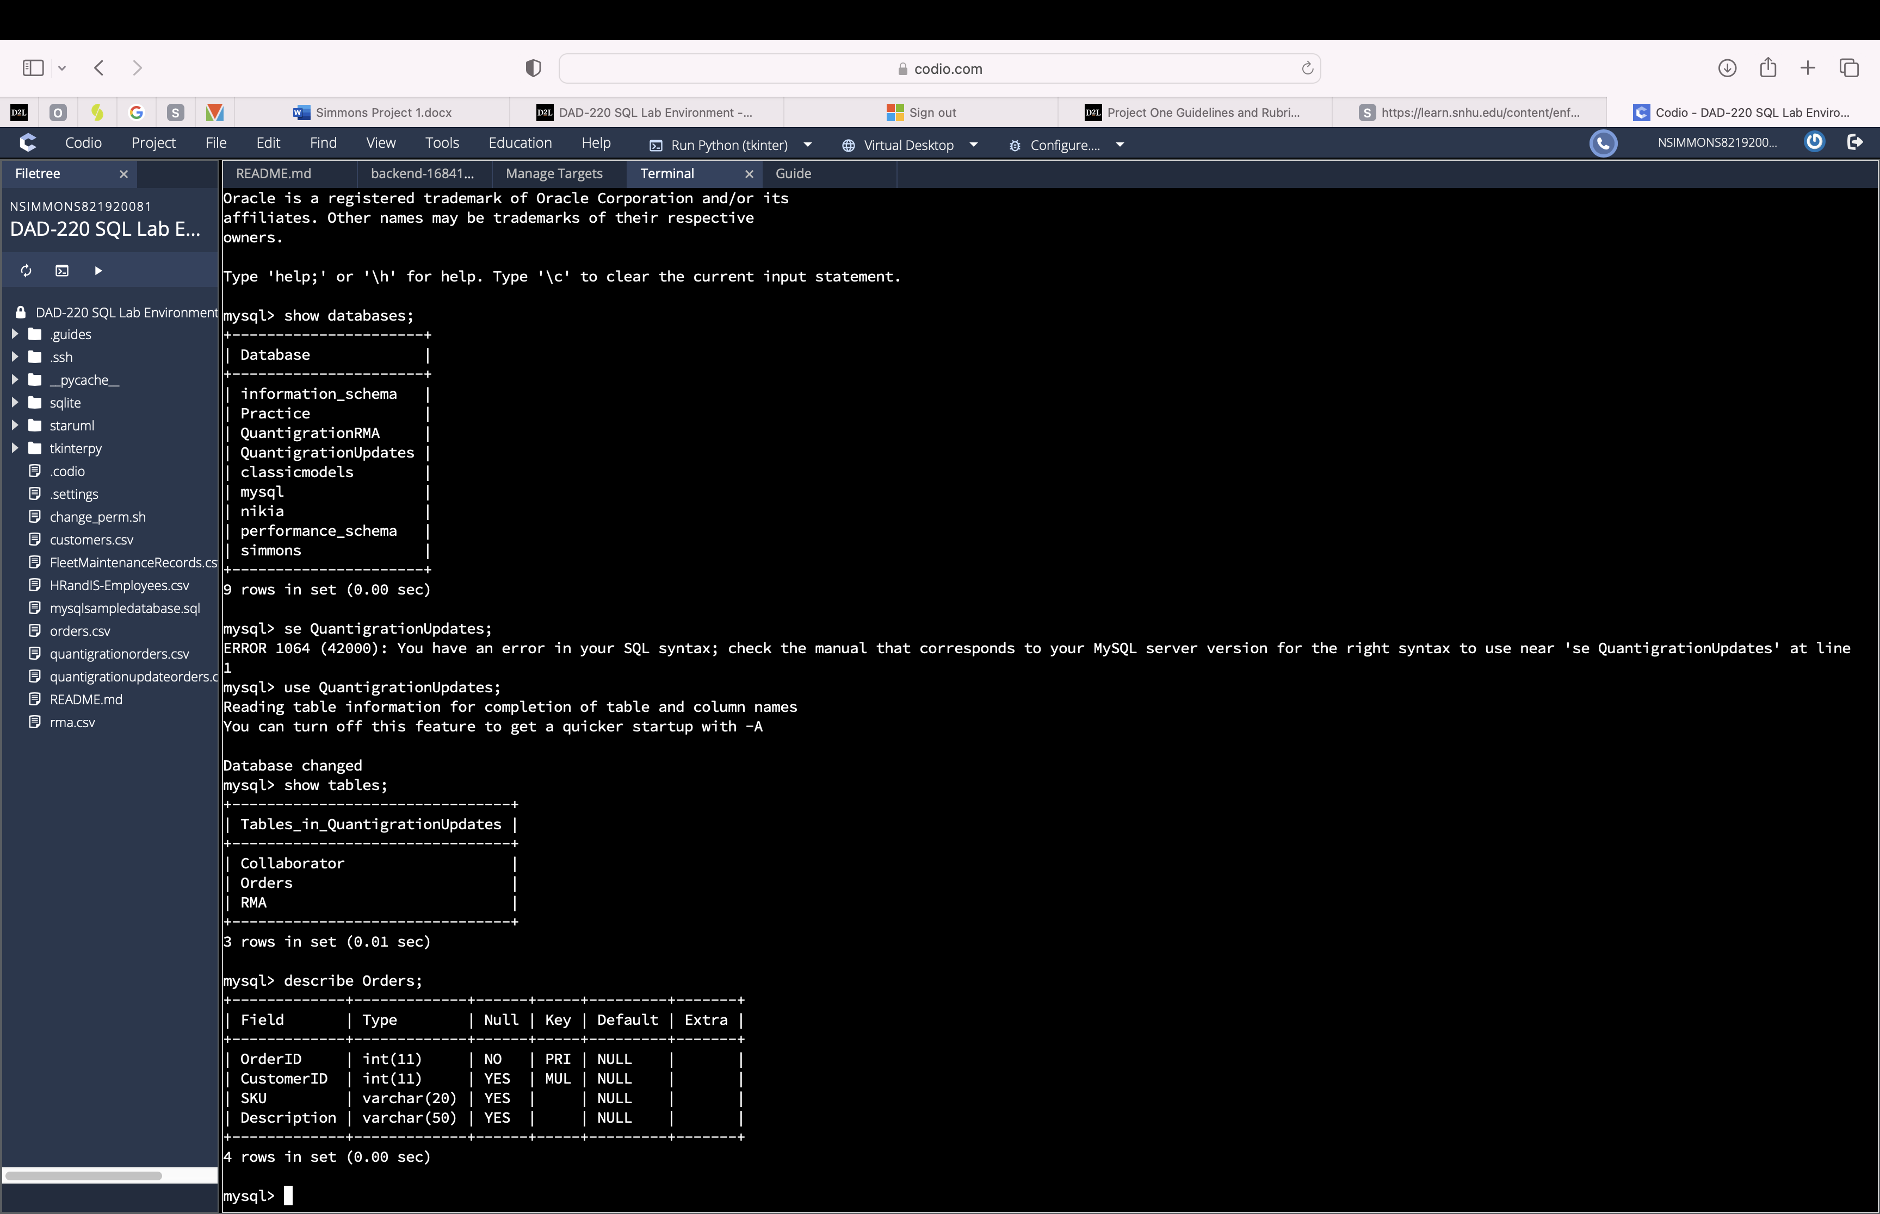

Code used:

CREATE TABLE Orders (

OrderID INT PRIMARY KEY,

CustomerID INT,

SKU VARCHAR(20),

Description VARCHAR(50) ) ;

ALTER TABLE Orders  
ADD FOREIGN KEY (CustomerID) REFERENCES Customers(CustomerID);

* 1. A table named **RMA** in the QuantigrationUpdates database, as defined on the project ERD. Provide the SQL commands you ran against MySQL to complete this successfully in your answer:

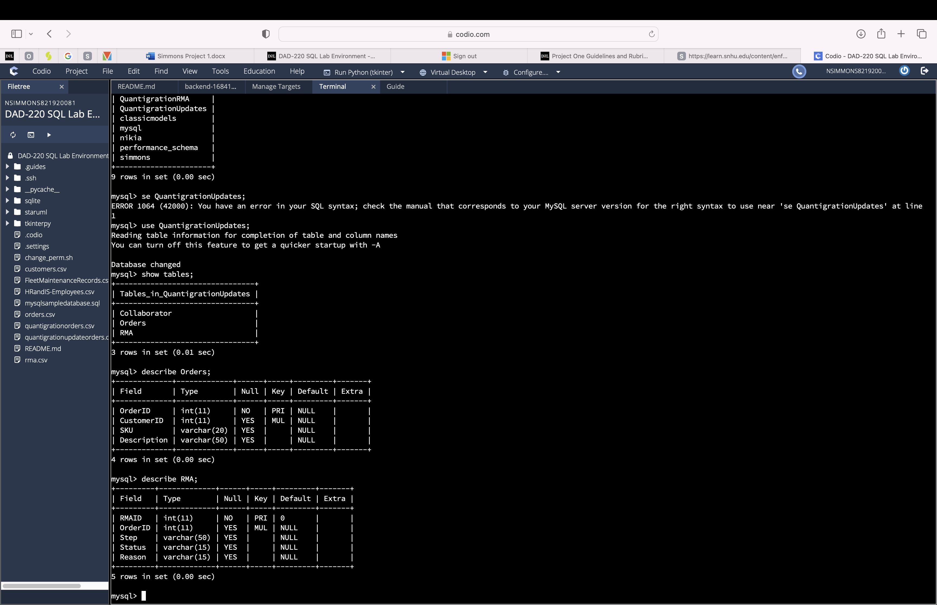

Code used:

CREATE TABLE RMA (

RMAID INT,

OrderID INT,

Step VARCHAR(50),

Status VARCHAR(15),

Reason VARCHAR(15) ) ;

ALTER TABLE RMA  
ADD PRIMARY KEY (RMAID) REFERENCES Orders(OrderID);

## Step Two: Load and Query the Data

1. **Import the data from each file into tables.**

· Use the QuantigrationUpdates database, the three tables you created, and the three CSV files preloaded into Codio.

· Use the import utility of your database program to load the data from each file into the table of the same name. You will perform this step three times, once for each table.

1. **Write basic queries against imported tables to organize and analyze targeted data.** For each query, replace the bracketed text with a screenshot of the query and its output. You should also include a 1- to 3-sentence description of the output.

· Write an SQL query that returns the **count** of orders for customers located only in the city of Framingham, Massachusetts.

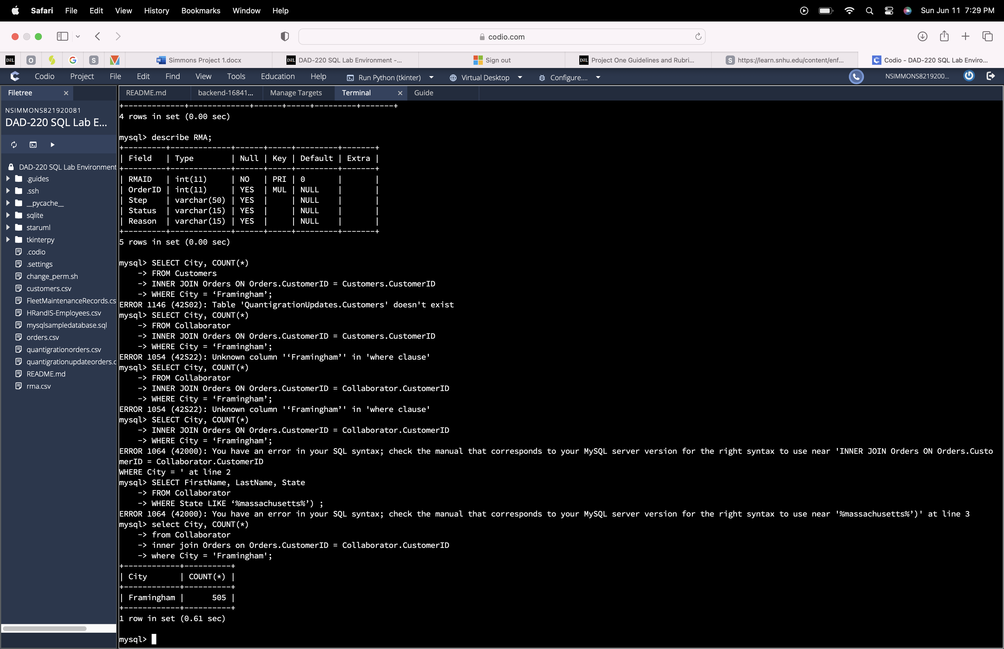

Code used:

SELECT City, COUNT(*)

FROM Customers

INNER JOIN Orders ON Orders.CustomerID = Customers.CustomerID

WHERE City = ‘Framingham’;

i. How many records were returned?

Answer: Framingham has 505 orders

· Write an SQL query to **select all** of the Customers located in the state of Massachusetts.

i. Use a WHERE clause to limit the number of records in the Customers table to only those who are located in Massachusetts.

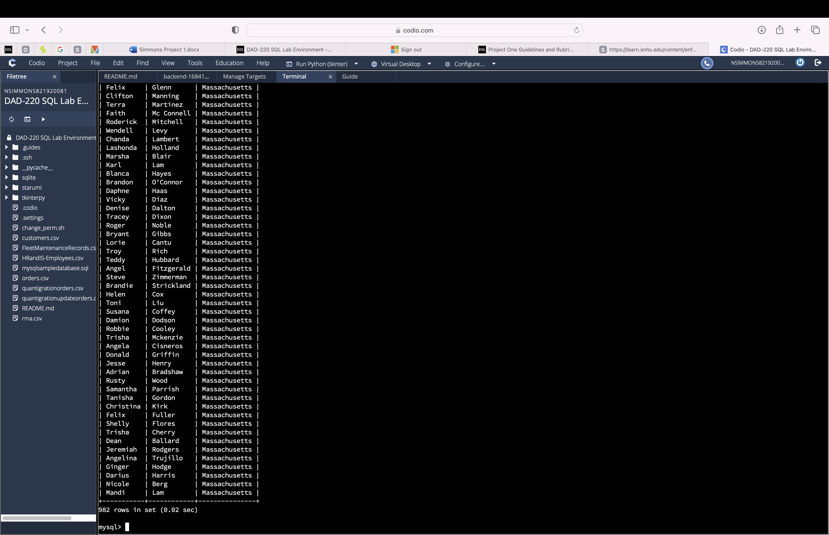

Code used:

SELECT FirstName, LastName, State

FROM Collaborator

WHERE State LIKE ‘%massachusetts%’ ;

ii. Record an answer to the following question: How many records were returned?

Answer: 982 rows

· Write a SQL query to insert four new records into the Orders and Customers tables using the following data:

**Customers Table**

|  |  |  |  |  |  |  |  |
| --- | --- | --- | --- | --- | --- | --- | --- |
| **CustomerID** | **FirstName** | **LastName** | **StreetAddress** | **City** | **State** | **ZipCode** | **Telephone** |
| 100004 | Luke | Skywalker | 15 Maiden Lane | New York | NY | 10222 | 212-555-1234 |
| 100005 | Winston | Smith | 123 Sycamore Street | Greensboro | NC | 27401 | 919-555-6623 |
| 100006 | MaryAnne | Jenkins | 1 Coconut Way | Jupiter | FL | 33458 | 321-555-8907 |
| 100007 | Janet | Williams | 55 Redondo Beach Blvd | Torrence | CA | 90501 | 310-555-5678 |

Code used:

INSERT INTO Customers (CustomerID, FirstName, LastName, Street, City, State, ZipCode, Telephone)

VALUES (100004, 'Luke', 'Skywalker', '15 Maiden Lane', 'New York', 'NY', '10222', '2125551234'), (100005, 'Winston', 'Smith', '123 Sycamore Street', 'Greensboro', 'NC', '27401', '9195556623'), (100006, 'MaryAnne', 'Jenkins', '1 Coconut Way', 'Jupiter', 'FL', '33458', '3215558907'), (100007, 'Janet', 'Williams', '55 Redondo Beach Blvd', 'Torrence', 'CA', '90501', '3105555678');

**Orders Table**

|  |  |  |  |
| --- | --- | --- | --- |
| **OrderID** | **CustomerID** | **SKU** | **Description** |
| 1204305 | 100004 | ADV-24-10C | Advanced Switch 10GigE Copper 24 port |
| 1204306 | 100005 | ADV-48-10F | Advanced Switch 10 GigE Copper/Fiber 44 port copper 4 port fiber |
| 1204307 | 100006 | ENT-24-10F | Enterprise Switch 10GigE SFP+ 24 Port |
| 1204308 | 100007 | ENT-48-10F | Enterprise Switch 10GigE SFP+ 48 port |

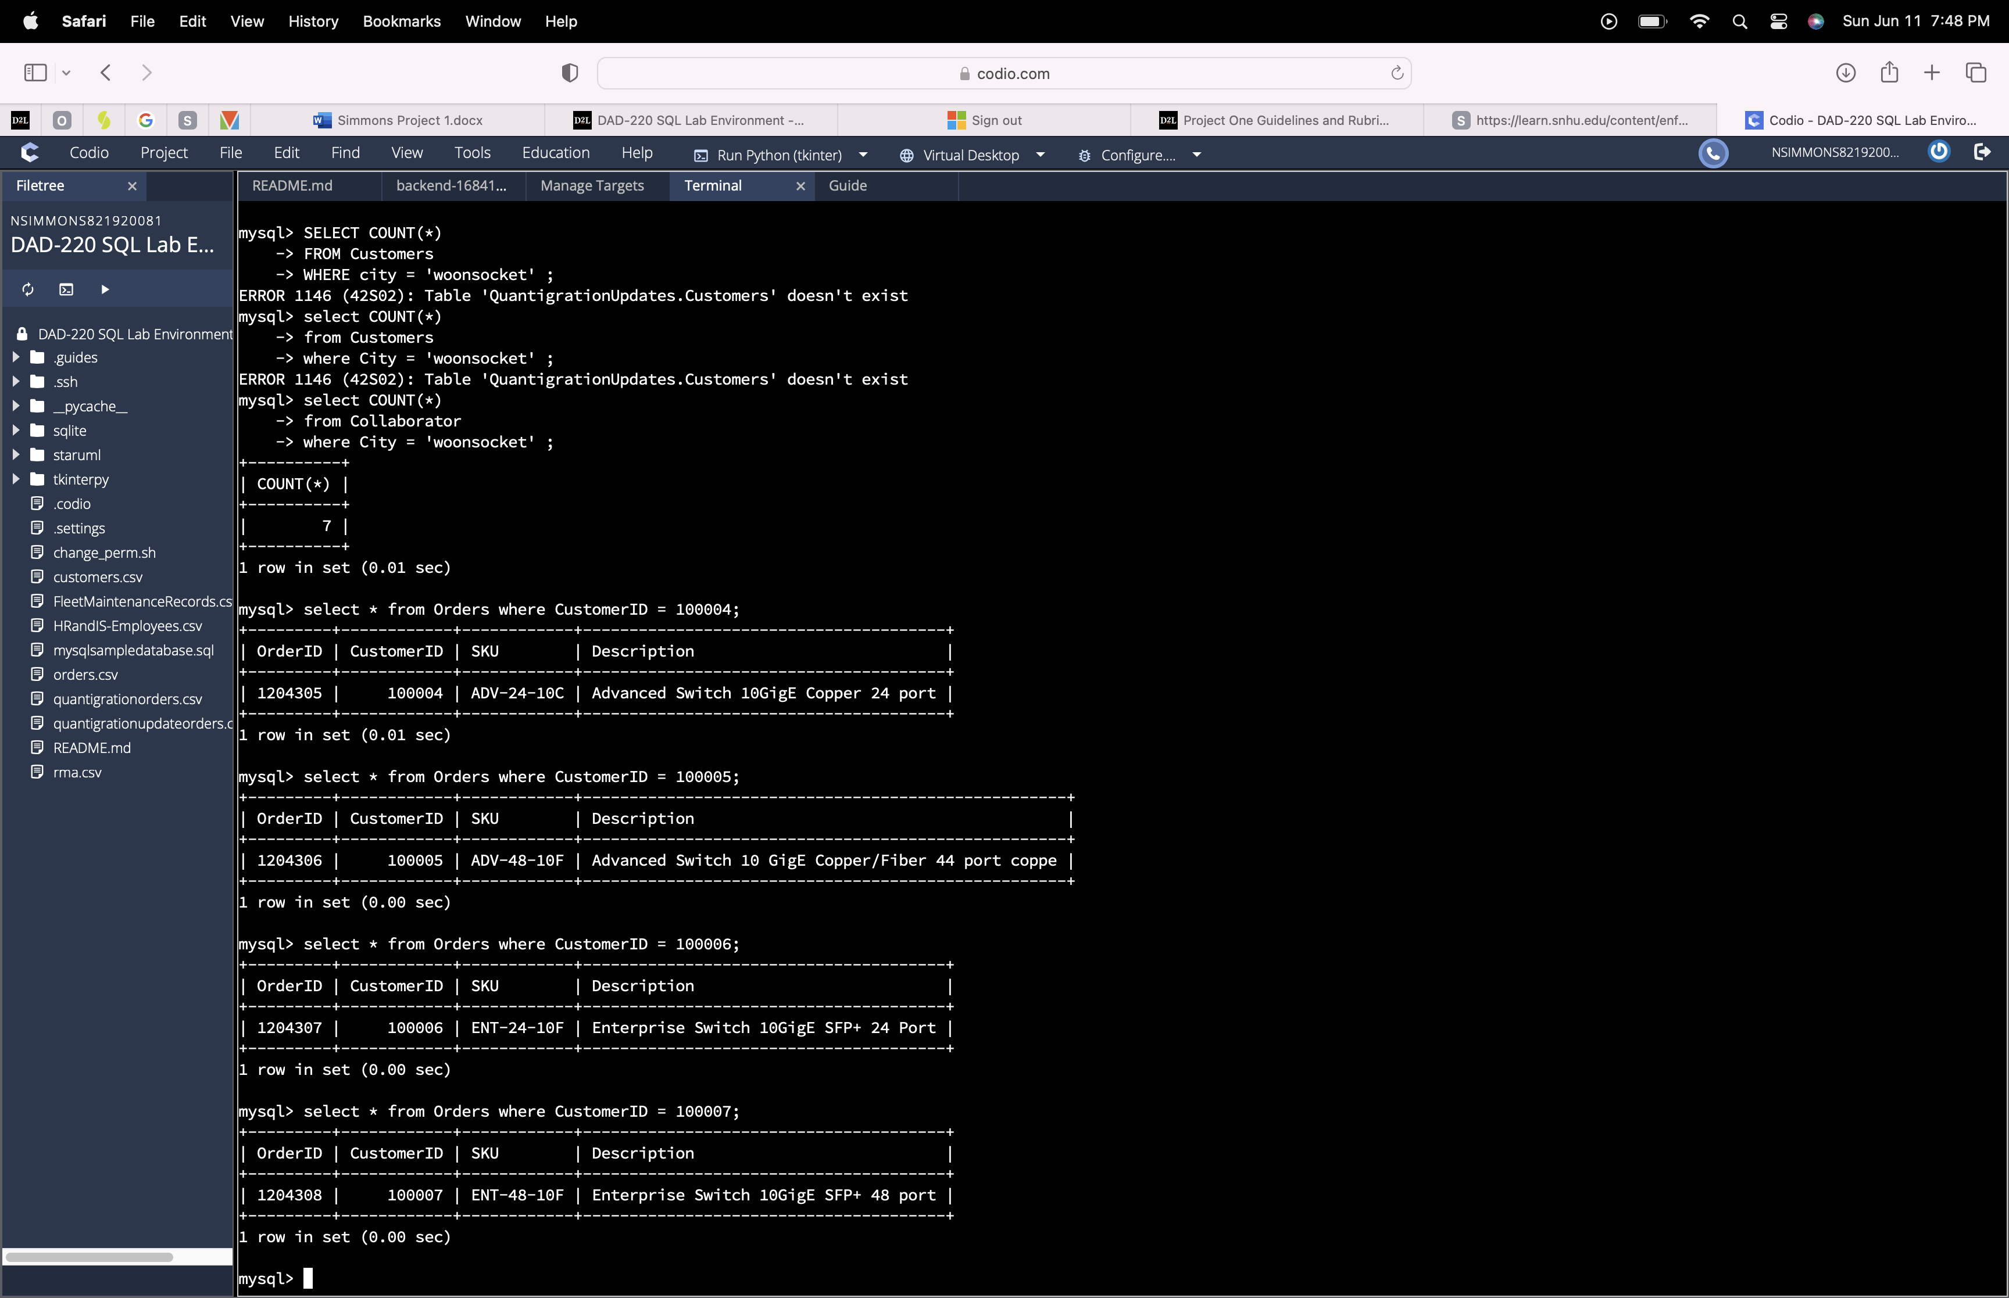

Code used:

INSERT INTO Orders (OrderID, CustomerID, SKU, Description)

VALUES (1204305, 100004, 'ADV-24-20C', 'Advanced Switch 10GigE Copper 24 port'), (1204306, 100005, 'ADV-48-10F', 'Advanced Switch GigE Copper/Fiber 44 port copper 4 port fiber'), (1204307, 100006, 'ENT-24-10F', 'Enterprise Switch 10GigE SFP+24 Port'), (1204308, 100007, 'ENT-48-10F', Enterprise Switch 10GigE SFP+ 48port') ;

· In the Customers table, perform a query to count all records where the city is Woonsocket, Rhode Island.

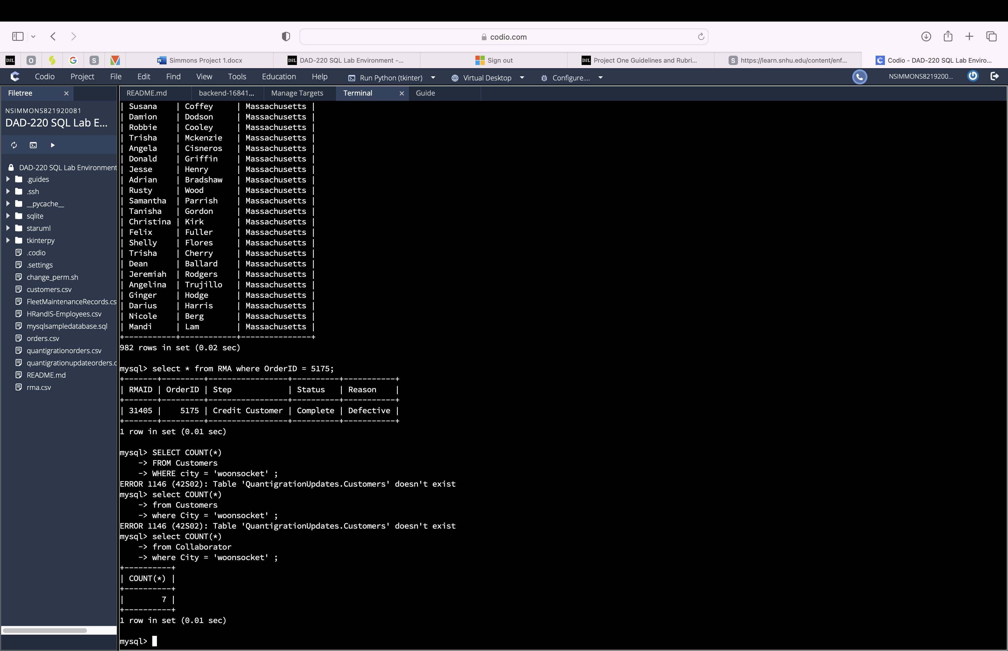

Code used:

SELECT COUNT(*)

FROM Customers

WHERE city = 'woonsocket' ;

This statement counts the amount of customers in the city of woonsocket.

i. How many records are in the Customers table where the field “city” equals “Woonsocket”?

Answer: 7

· In the RMA database, update a customer’s records.

i. Write an SQL statement to select the current fields of **status** and **step** for the record in the **RMA** table with an **orderid** value of “5175.”

Code used:

SELECT Status, Step

FROM RMA

WHERE OrderID = 5175;

This statement shows the information from every column in the table RMA where the OrderID is 5175.

1. What are the current status and step?

Answer: Pending and Awaiting customer Documentation

ii. Write an SQL statement to update the **status** and **step** for the **OrderID**, 5175 to **status** = “Complete” and **step** = “Credit Customer Account.”

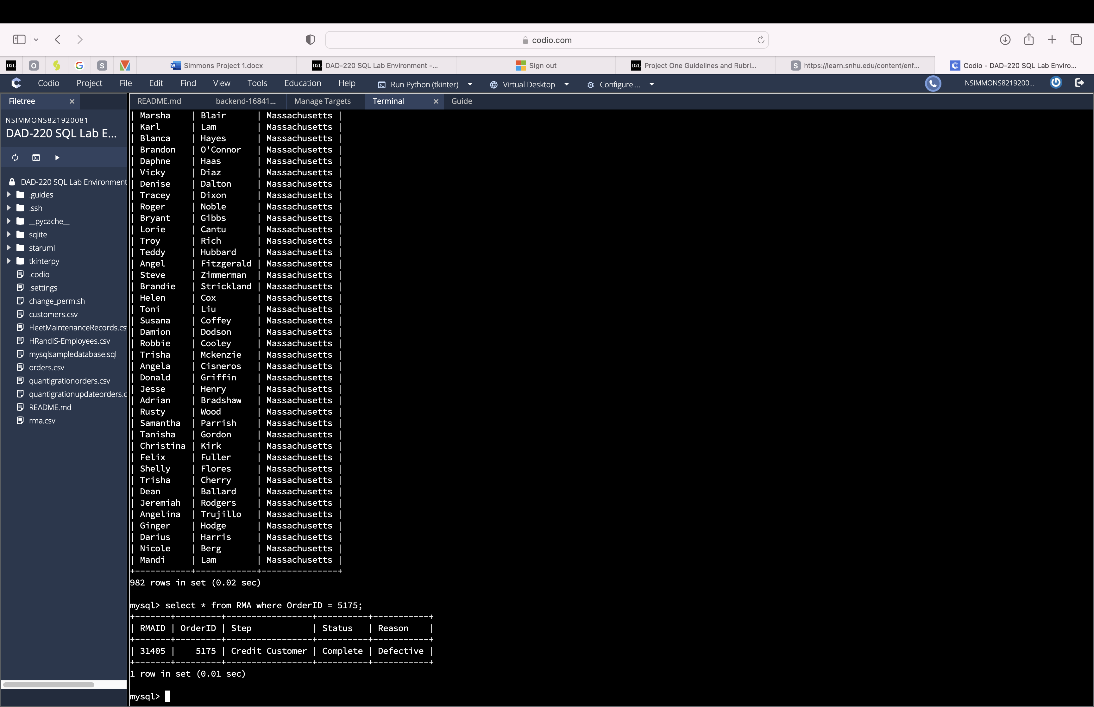

Code used:

UPDATE RMA

SET Status = 'Complete', Step = 'Credit Customer'

WHERE OrderID = 5175;

This statement changes the status and step in the row that has an OrderID of 5175.

1. What are the updated **status** and **step** values for this record?

Answer: 31405 | 5175 | Credit Customer | Complete | Defective

· Code used: Delete RMA records.

i. Write an SQL statement to delete all records with a reason of “Rejected.”

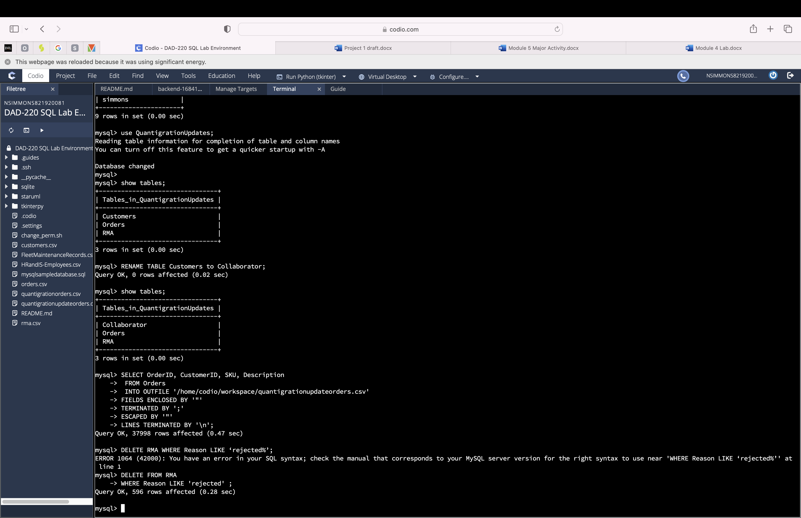

Code used:

DELETE FROM RMA

WHERE Reason LIKE 'rejected' ;

This statement uses the where clause to narrow the list that is to be deleted from the RMA table. Any row with rejected in the reason column is deleted.

1. How many records were deleted?

Answer: 596

1. **Update your existing tables** from “Customer” to “Collaborator” using SQL based on this change in requirements. Provide the SQL commands you ran against MySQL to complete this successfully in your answer:
   1. Rename all instances of “Customer” to “Collaborator.”

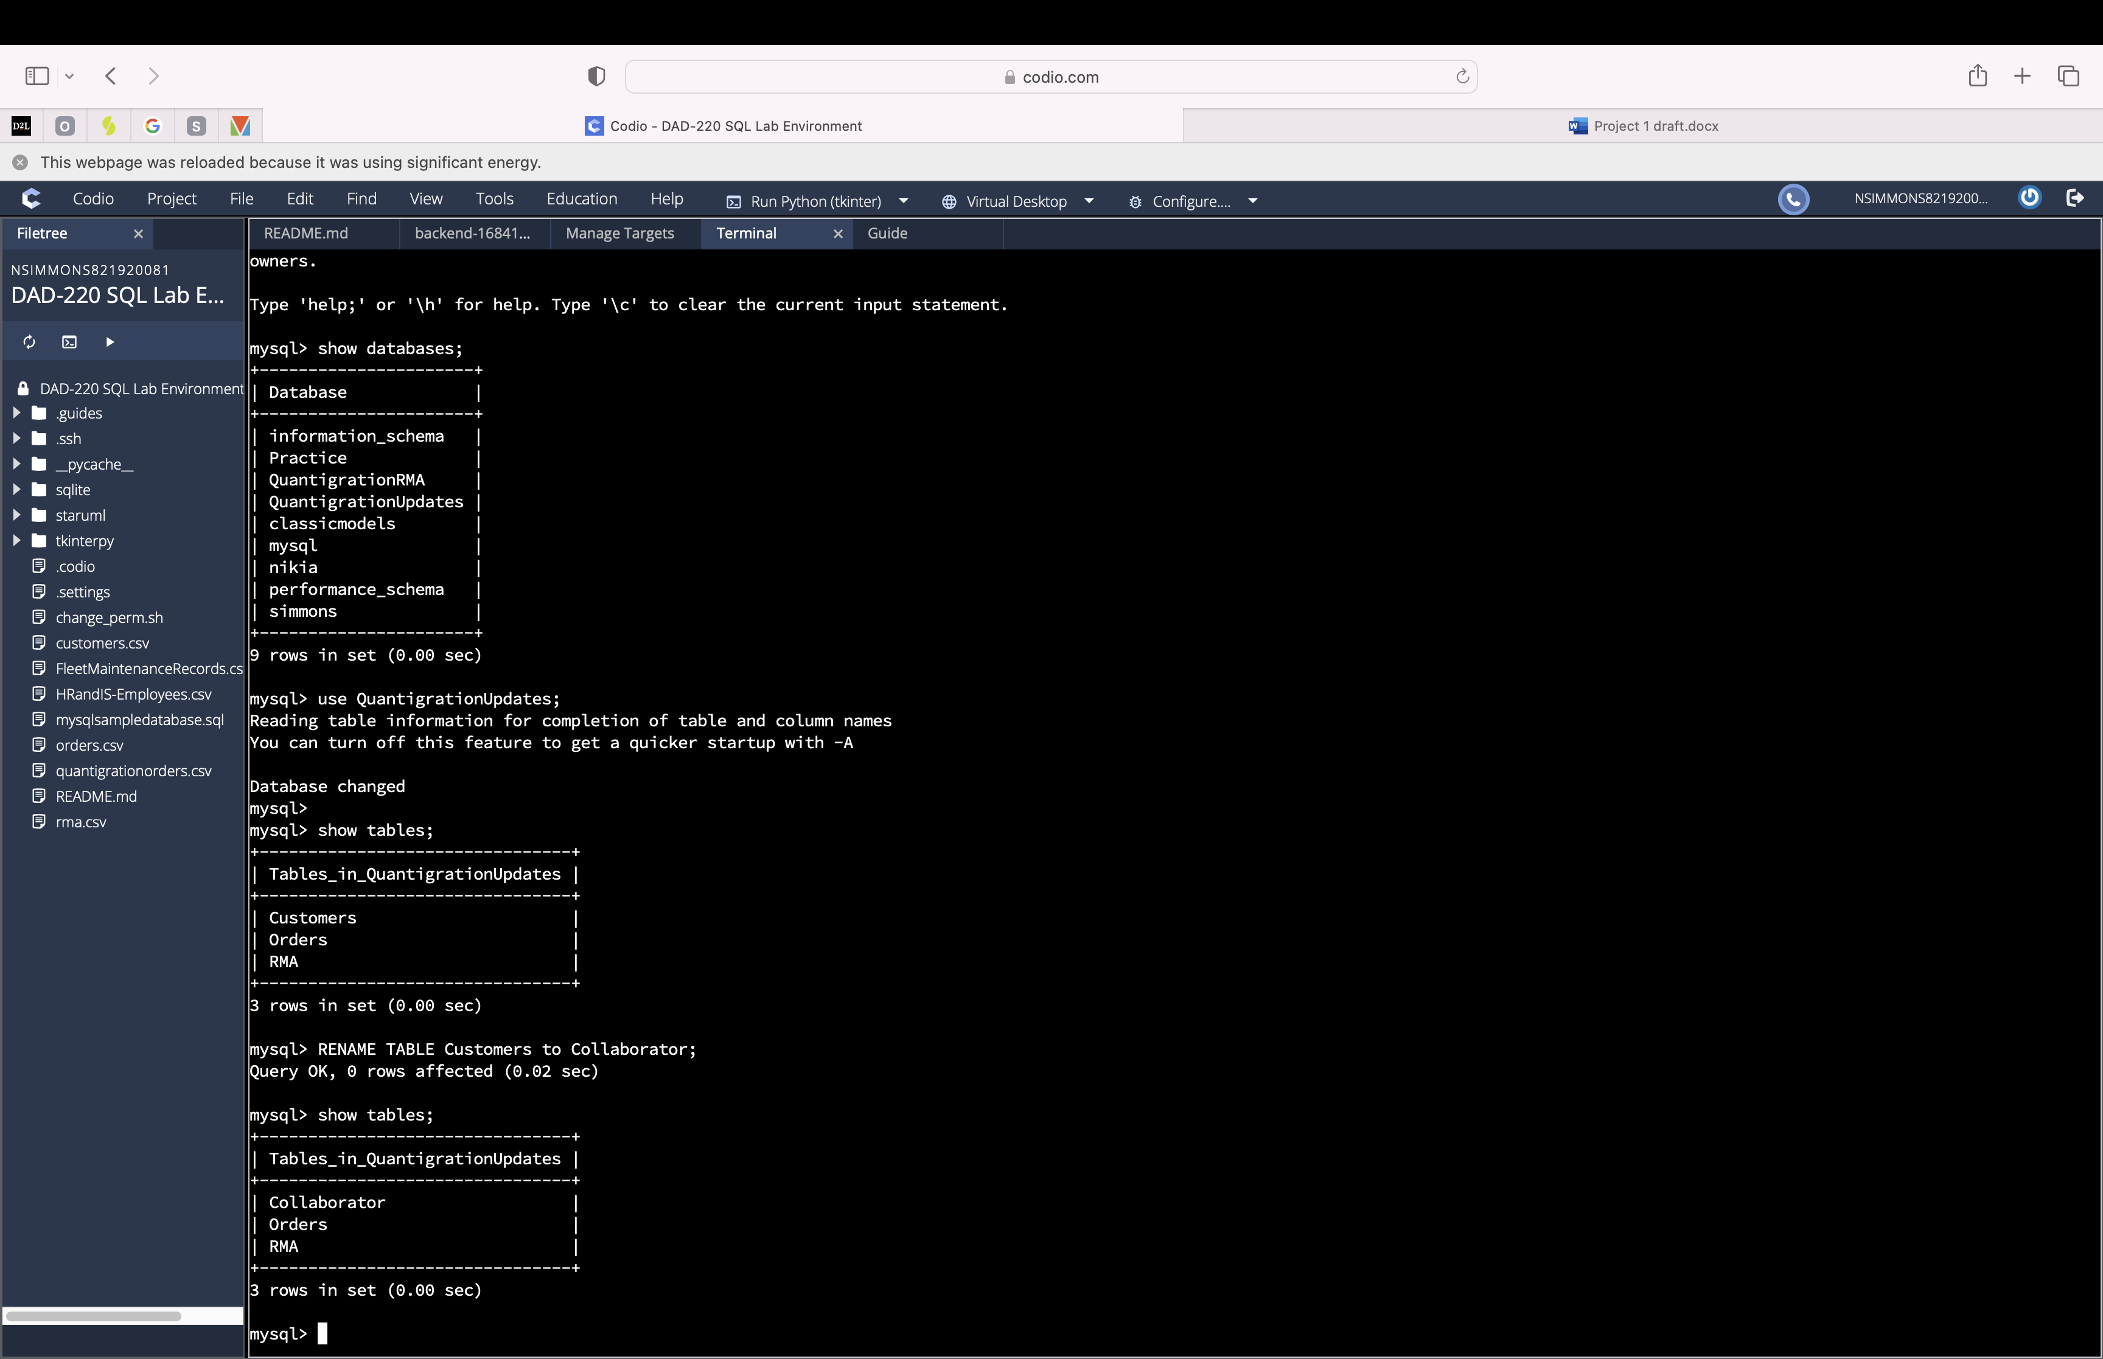

Code used: RENAME TABLE Customers to Collaborator

This code changed the name of the existing table Customers to Collaborator.

1. **Create an output file of the required query results.** Write an SQL statement to list the contents of the **Orders** table and send the output to a file that has a .csv extension.

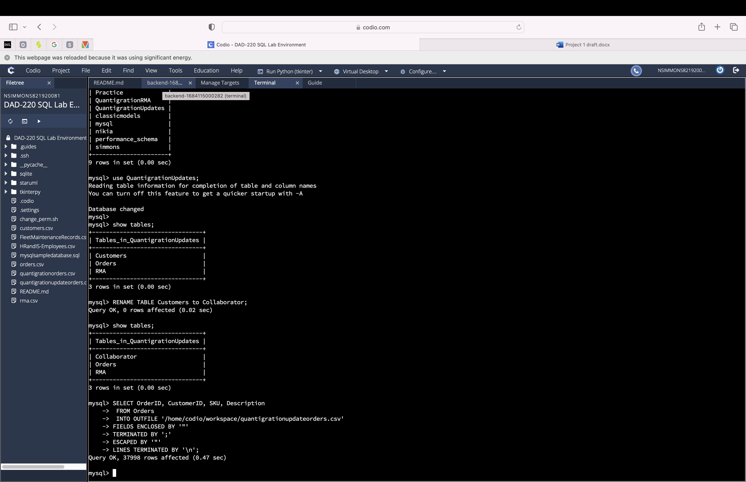

Code used:

SELECT OrderID, CustomerID, SKU, Description

FROM Orders

INTO OUTFILE '/home/codio/workspace/quantigrationupdateorders.csv'

FIELDS ENCLOSED BY '"'

TERMINATED BY ';'

ESCAPED BY '"'

LINES TERMINATED BY '\n';

This code writes data from the database into a file.

SELECT Specifies which part columns from the table to choose. FROM chooses which table to gather the data from.

WHERE is optional and filters the rows based on certain conditions.

INTO OUTFILE specifies the file path where you want to save the query result. The remainder of the syntax is the format, field delimiter, and line terminator. These options are not mandatory and depend on your specific requirements.